Category 6A Shielded Keystone Jack Ultra Slim

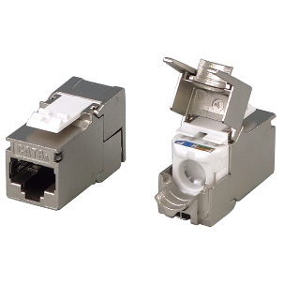

Category 6A shielded keystone jack supports the 10/100/1G BASE-T Ethernet, as well as advanced new 10G BASE-T Ethernet. The shielded jack with industrial leading transmission performance and provide exceptional levels of headroom, meets and exceeds ANSI/TIA-568.2-D and ISO/IEC 11801 2nd edition Category 6A standards. Zinc-alloy metal shell balances/eliminates the Alien crosstalk while the data is at high speed transmission. Ultra Slim design and half U design fits 0.5U 24-port, 1U 24-port & 1U 48-port empty panel for most efficient use of rack space.

Features

Zinc-alloy metal shell

Half U (0.5U) system compatible

Tool-free

Contacts are phosphor bronze plated with 50 micro inches hard gold

Dual T568A &amp; T568B wiring

Polycarbonate 94V0 rated

Itertek ETL / Force EC Cat.6

4PPoE compliant in accordance with IEEE802.bt Type 4

Ordering Information

|  |  |
| --- | --- |
| PART | Description |
| 1C68TPZA0 | RJ45, 8-Conductor Cat.6A ,Tool-free, Shielded, 180 degree, Ultra Slim, fits 0.5U panel |
| 1C68TPZA1 | RJ45, 8-Conductor Cat.6A ,Tool-free, Shielded, 180 degree, Ultra Slim, fits 0.5U panel, no cable tie required |
| 7C68TPZA0 | RJ45, 8-Conductor Cat.6A , Tool-free, Shielded, 180 degree, Ultra Slim, fits 0.5U panel |